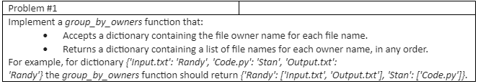

**Solution:-**

[**https://replit.com/@shruthi26/groupbyowners#main.py**](https://replit.com/@shruthi26/groupbyowners#main.py)

**Output**

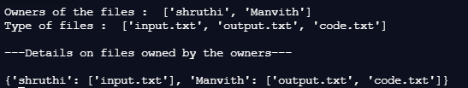



**Solution:-**

[**https://replit.com/@shruthi26/palindrome#main.py**](https://replit.com/@shruthi26/palindrome#main.py)

**Output**







**Solution:-**

[**https://replit.com/@shruthi26/log#main.py**](https://replit.com/@shruthi26/log#main.py)

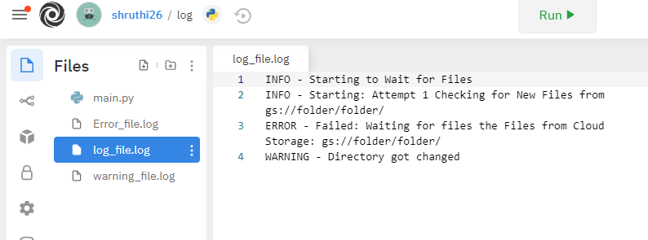

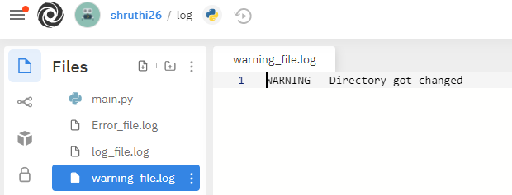

**Output**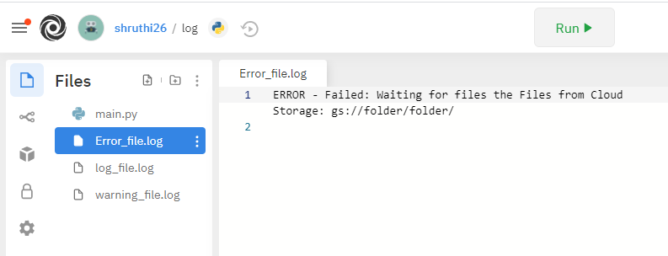

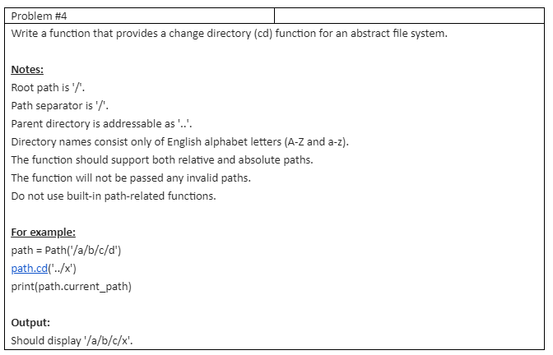

**Solution:-**

[**https://replit.com/@shruthi26/changedirectory#main.py**](https://replit.com/@shruthi26/changedirectory#main.py)

**Output**



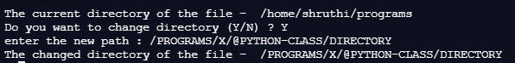



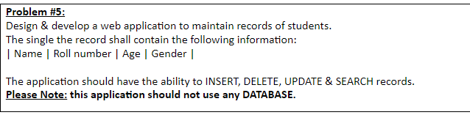

**Solution:-**

[**https://replit.com/@shruthi26/stddata#main.py**](https://replit.com/@shruthi26/stddata#main.py)

**Output**

